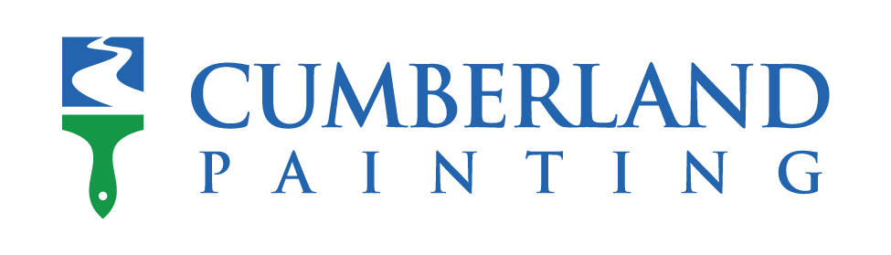

**Residential and Commercial Project Manager**

Cumberland Painting is looking for experienced Project Manager for both commercial and residential painting projects. Cumberland Painting’s mission is to build a successful organization through high employee satisfaction that will lead to the high customer satisfaction.

* Must pass a background check
* Supporting commercial and residential clients with all the necessary preparations for their project.
* Hiring, managing, and overseeing the work of all painters
* Coordinating scheduling with our customers and contractors.
* Overseeing projects to ensure high quality work is delivered quickly, cleanly, professionally, and as promised.
* Ensuring customers are blown away by going the extra mile and following our systems and standard operating procedures.
* Organization of all client information, contractor information, schedules, and job details.
* Recruiting phenomenal painters to work with us and deliver on our promises to our customers.
* Creating relationships with local paint representatives while assisting in managing expenses and revenues of each project
* Creating long term, win-win partnerships with our contractors and upholding our commitment to contractor success.
* Supporting marketing initiatives, co-creating ideas, and gathering creative media.
* Generating referrals through exceptional service and your ability to build genuine connections.
* Spearheads new ideas and initiatives, and regularly raises our company average as a whole
* Proficient in Stack and Paintscout software is a plus
* The ability to speak Spanish is a big plus but not required.

**COMPENSATION & BENEFITS**

* **Salary Range**: $70,000-$80,000 Per Year
* **Company Bonus Plan:**$25,000+ in yearly bonuses available.
* **Benefits:** Health Insurance, Vision & Dental, Gas & Phone Stipend
* **Flexible PTO:**Vacation, Sick, Personal, Maternity/Paternity Leave
* **Hybrid Schedule:**Work in the field, in the office and from home